# 1 Background

## 1.1 Semantic web and Ontology Introduction

The Semantic Web, sometimes known as Web 3.0, is an extension of the World Wide Web through standards set by the World Wide Web Consortium (W3C). The goal of the Semantic Web is to make Internet data machine-readable.

Semantic web is developed based on Ontology. Ontology[1] (or vocabularies) defines the concepts and relationships (also referred to as “terms”) used to describe and represent an area of concern. Vocabularies are used to classify the terms that can be used in a particular application, characterize possible relationships, and define possible constraints on using those terms. In practice, vocabularies can be very complex (with several thousands of terms) or very simple (describing one or two concepts only)

Ontology can also be understood as **data model.**

The role of ontology is to help data integration when, for example, ambiguities may exist on the terms used in the different data sets, or when a bit of extra knowledge may lead to the discovery of new relationships

Reference: <https://arxiv.org/pdf/1006.4567.pdf>

## 1.2 Triple

A triple[2] is a set of three entities that codifies a statement about semantic data in the form of **subject–predicate–object** expressions (e.g., "Bob is 35", or "Bob knows John"). This format enables knowledge to be represented in a machine-readable way.

A triple can be represented in multiple formats[3] such as RDF/XML, RDFa, Notation3[4], and Turtle[5].

Typical **turtle** representation:

Subject predicate1 object1;

predicate2 object2;

predicate3 object3, object4.

For example, in the following triple

<<http://www.example.org/index.html>> <hasCreator> "John Smith" .

* Subject is the web page **http://www.example.org/index.html**
* Predicate is the **hasCreator** property
* Object is the String **"John Smith"**.

## 1.3 Ontology components

Ontology includes three main components: concepts (or classes), instances, and properties

A Concept (also known as a class or a term) is an abstract group, set, or collection of objects. It is the fundamental element of the domain and usually represents a group or class whose members share common properties. This component is represented in hierarchical graphs, such that it looks similar to **object-oriented systems**. The concept is represented by a “super-class”, representing the higher class or so-called “parent class”, and a “subclass” which represents the subordinate or so-called “child class”.

Individuals (instances or objects) are the basic, "ground level" components of an ontology. The individuals in an ontology may include concrete objects such as people, animals, tables, automobiles, molecules, and planets. Strictly speaking, an ontology need not include any individuals, but one of the general purposes of an ontology is to provide a means of classifying individuals, even if those individuals are not explicitly part of the ontology.

Individuals have properties, to store their information. There are two types of properties:

**Data property**

Data properties connect individuals with literals. In some knowledge representation systems, functional data properties are called attributes. Examples of data properties are: hasName, hasPhoneNumber, etc.

**Object properties**

Object properties connect two individuals. Example of object properties are isTaughtBy, supervises, etc.

Each property has domains and ranges

* **Property domain**s: specify which classes that the property belongs to
* **Property range**: specify the possible value of the property

Example:

:age a owl:DatatypeProperty;

rdfs:domain foaf:Person;

rdfs:range xsd:nonNegativeInteger .

:isTaughtBy a owl:ObjectProperty;

rdfs:domain :Course;

rdfs:range :AcademicStaffMember;

rdfs:subPropertyOf :involves.

## 1.4 Vietnamese Tourism ontology

Vietnamese tourism ontology is a unified and common representation of data in tourism domain. It involves many subjects of history and culture as a natural feature of tourism.

Link download: <https://drive.google.com/drive/folders/1QGoKV4hWqQzi2LGo8T8Fu30LzZPc3nwL?usp=sharing>

The ontology can be opened with **protege** software <https://protege.stanford.edu/>

## 1.5 Websites to collect Tourism data

There are numerous websites where we can collect tourism data. Examples are Wikipedia, Wikidata.org, DBpedia.org, and the websites of the department of culture and tourism in many cities and provinces in Vietnam.

For example, using Wikipedia, you can parse the data represented in the infobox.

<https://vi.wikipedia.org/wiki/Ch%C3%B9a_M%E1%BB%99t_C%E1%BB%99t>

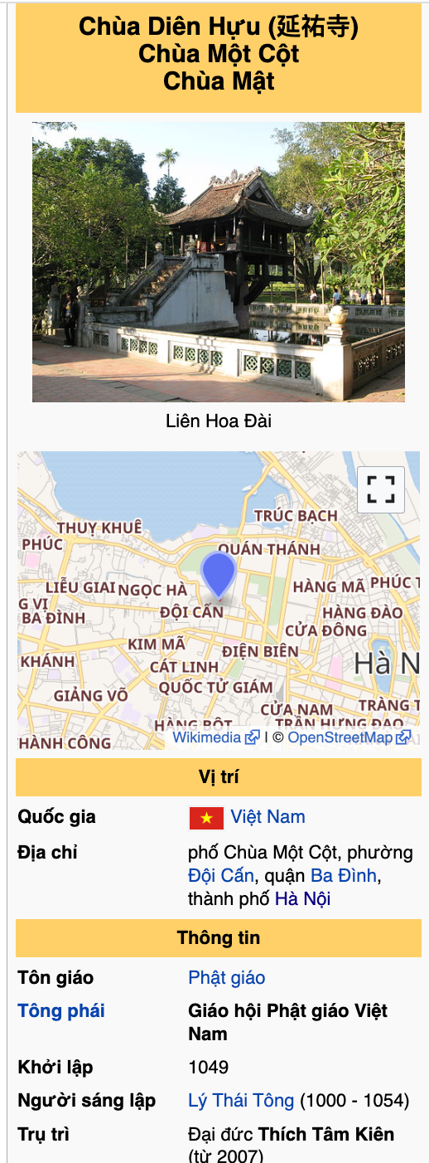

Using the following query with the DBPedia SPARQL endpoint, we can roughly get famous people in Vietnam. Visit <https://www.w3.org/TR/rdf-sparql-query/> to learn SPARQL.

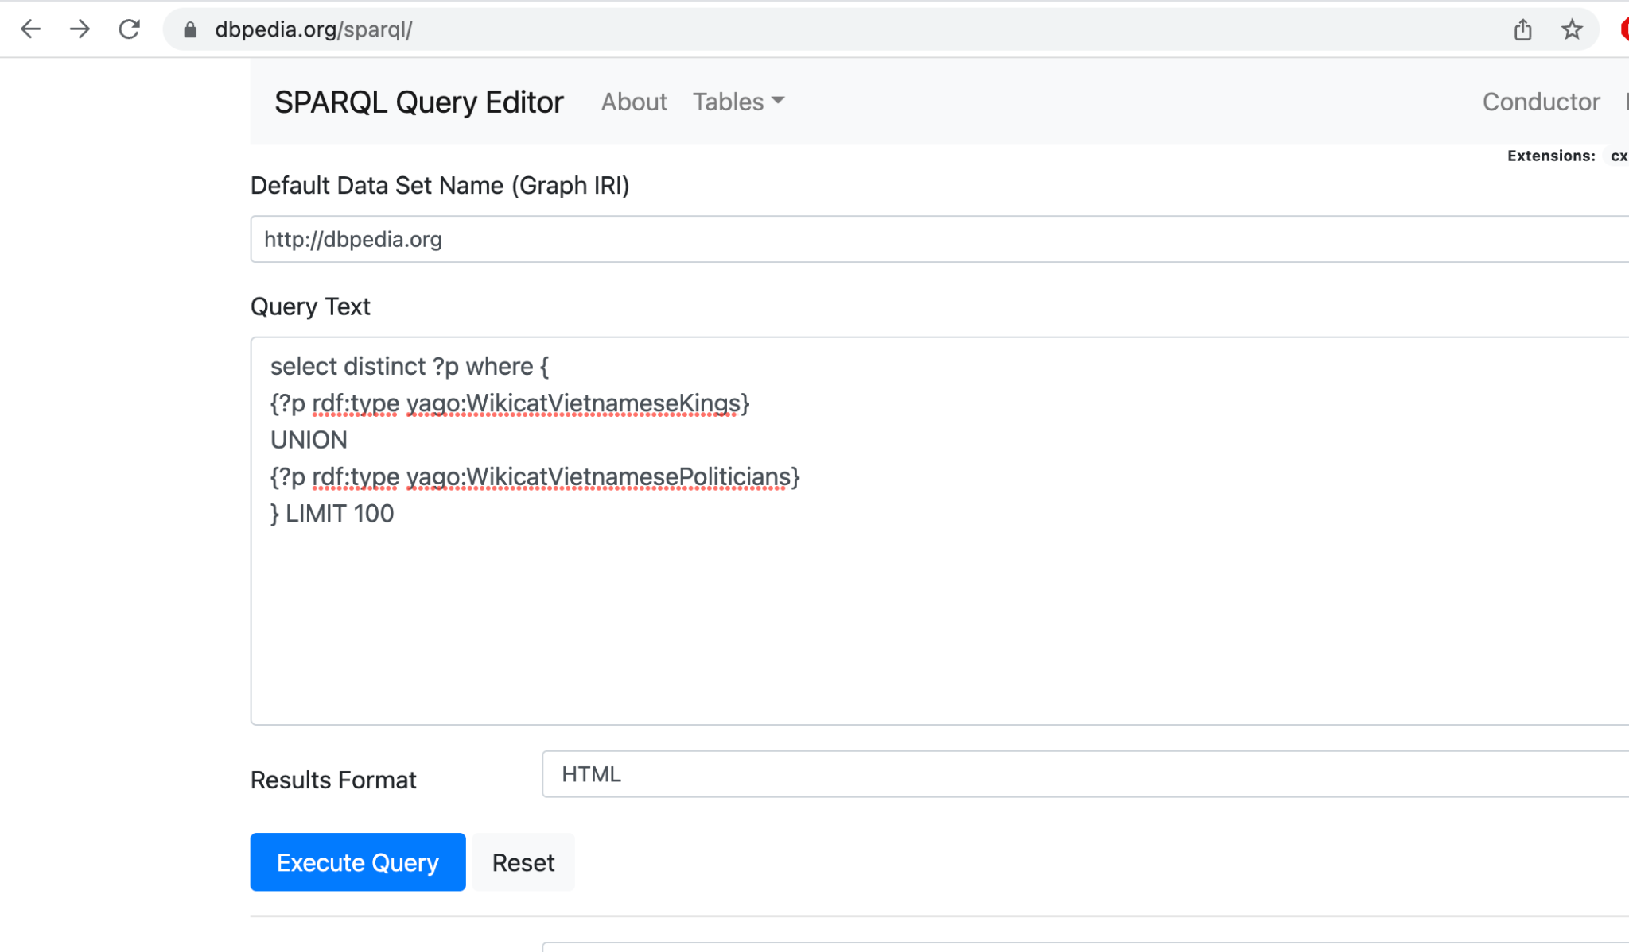

select distinct ?p where {

{?p rdf:type yago:WikicatVietnameseKings}

UNION

{?p rdf:type yago:WikicatVietnamesePoliticians}

} LIMIT 100

Similarly, you can use the SPARQL endpoint from Wikidata

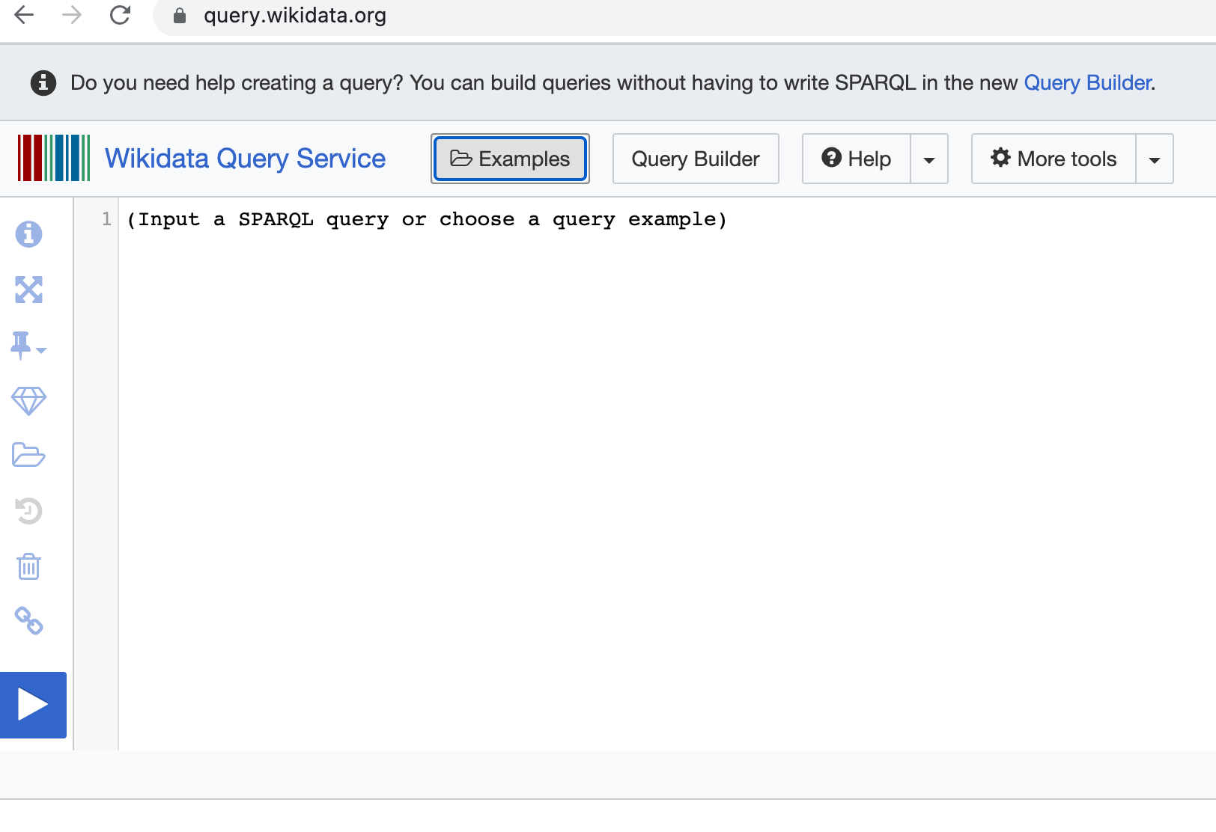

Many other websites provide data on tourism, but the data is unstructured. Examples are

* Hoidulich.net
* Khamphadisan.com
* http://lehoi.info/

2 Problem description

You need to understand the tourism ontology, collect tourism data from tourism websites, and store the data in files using the turtle[6] format. Each topic needs to be stored in separate file.

You will get a high score if you be able to collect a huge amount of data on various topics and the data must be precise.

Example turtle representations:

@prefix vntourism: <http://www.semanticweb.org/minhn/ontologies/2021/0/vntourism#> .

vntourism:Cổ_Loa_Citadel rdf:type owl:NamedIndividual ,

vntourism:CitadelArchitecture ;

vntourism:chosenCapitalBy vntourism:An_Dương_Vương ,

vntourism:Ngô_Quyền ,

vntourism:Ngô_Xương_Văn ;

vntourism:hasAdministrativeDivision vntourism:Hà_Nội ;

vntourism:hasBuildBy vntourism:An_Dương_Vương ;

vntourism:hasBuildTime "3rd century"@en ;

vntourism:hasCountry vntourism:AuLac ;

vntourism:hasFestival vntourism:Lễ_hội_Cổ_Loa ;

vntourism:hasHistoricalSiteLevel vntourism:SepcialNationalLevel ;

vntourism:hasPeriod vntourism:NgoDynasty ;

rdfs:label "Cổ Loa Citade"@en ,

"Thành Cổ Loa"@vn .

:Ly_Thuong_Kiet_Working_TimeLine

rdf:type owl:NamedIndividual, :TemporalEntity;

:hasBeginning [

rdf:type :Instant ;

:inTimePosition [

rdf:type :TimePosition ;

:hasJob :Kinh_Phong_Su_Lý_Thường_Kiệt;

:year "1061"^^xsd:gYear

]

] ;

:hasDurationDescription [

rdf:type :GeneralDurationDescription ;

:year "8"^^xsd:gYear

] ;

:hasEnd [

rdf:type :Instant ;

:inTimePosition [

rdf:type :TimePosition ;

:year "1069"^^xsd:gYear

]

] .

1. <https://www.w3.org/standards/semanticweb/ontology>
2. <https://en.wikipedia.org/wiki/Semantic_triple>
3. <https://ontola.io/blog/rdf-serialization-formats/>
4. <https://www.w3.org/TeamSubmission/n3/>
5. ​​<https://www.w3.org/TR/turtle/>
6. ​​<https://www.w3.org/TR/turtle/>